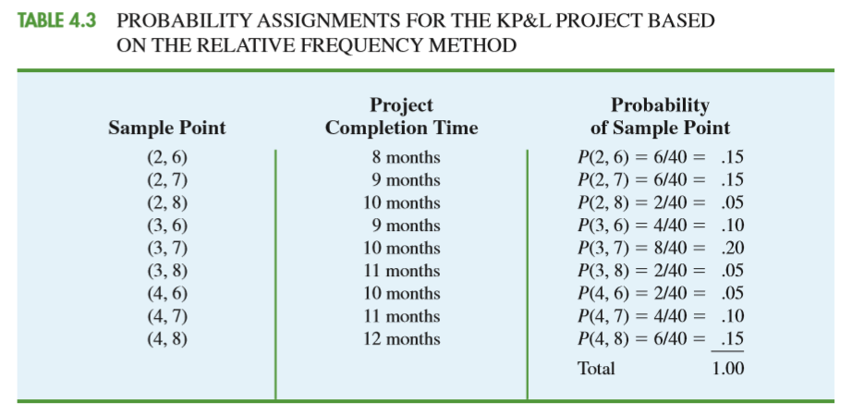

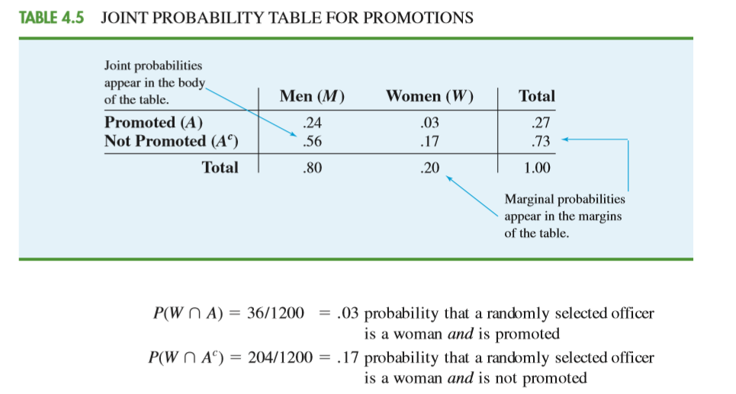

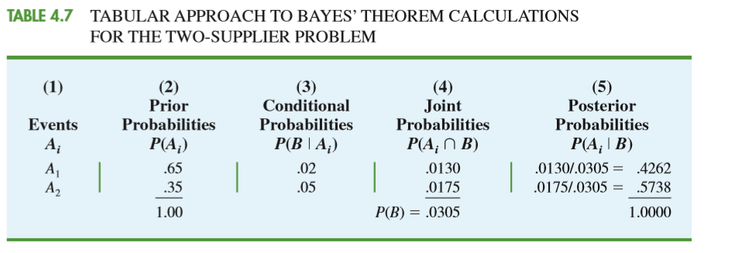

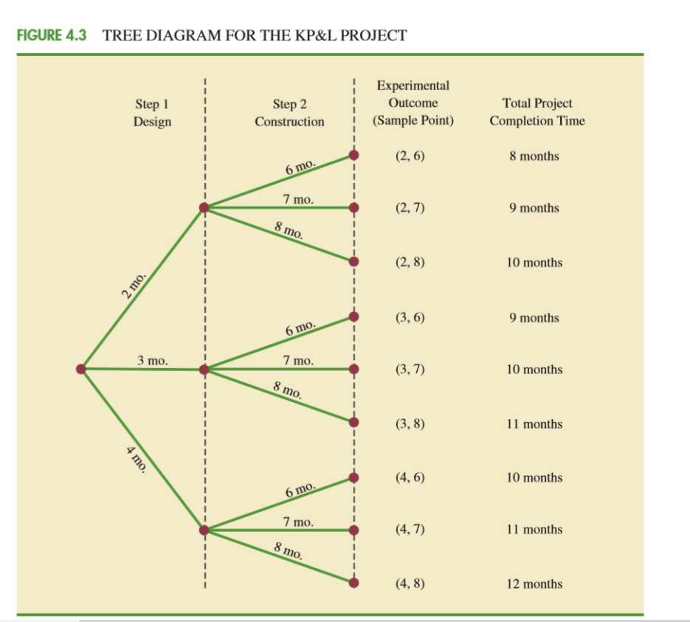

* **Rule of Subtraction** The probability that event A will occur is equal to 1 minus the probability that event A will not occur.
* P(A) = 1 - P(A')
* **Occur | Not occur**
* **Rule of Multiplication**  The probability that Events A and B both occur is equal to the probability that Event A occurs  **times the probability that Event B occurs, given that A has occurred.**
* P(A ∩ B) = **P(A) P(B|A)**
* The rule of multiplication applies to the situation when we want to know the probability of the **intersection of two events**; that is, we want to know the probability that two events **(Event A and Event B) both occur**.
* The rule of addition applies to the following situation. We have two events, and we want to know the probability that **either event occurs.**
* **Rule of Addition** The probability that Event A or Event B occurs **is equal** to the
* probability that Event A occurs plus the probability that Event B occurs minus the **probability that both Events A and B occur.**
* P(A ∪ B) = P(A) + P(B) - P(A ∩ B)